Fragments GitHub:
https://github.com/MansoorAZafar/fragments
Fragments Lab 9 Hurl:
(It shows an x for an individual, but that’s pushing to docker from a branch, which can’t happen and overall, the fragments is a checkmark green. I push to a branch then merge; the branch can’t push to docker)
https://github.com/MansoorAZafar/fragments/blob/main/tests/integration/lab-9-s3.hurl

Test Integration Lab 9 Passing when ran again fragments Server
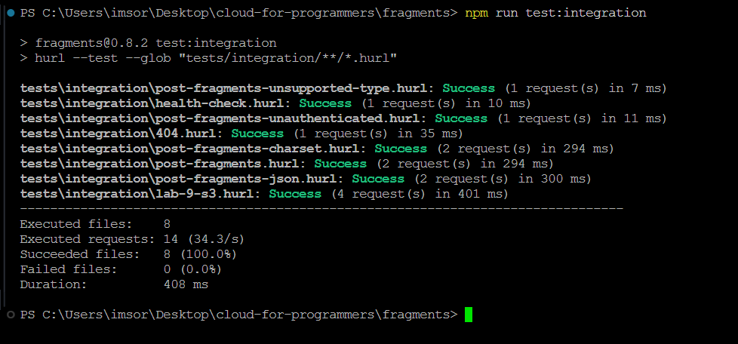
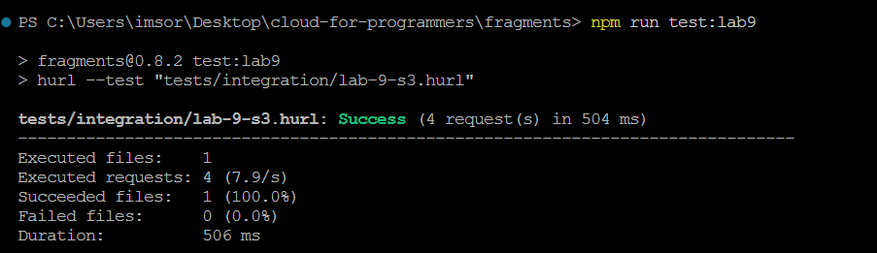
Test Integration Lab 9 Passing when ran again LocalStack using Docker Compose
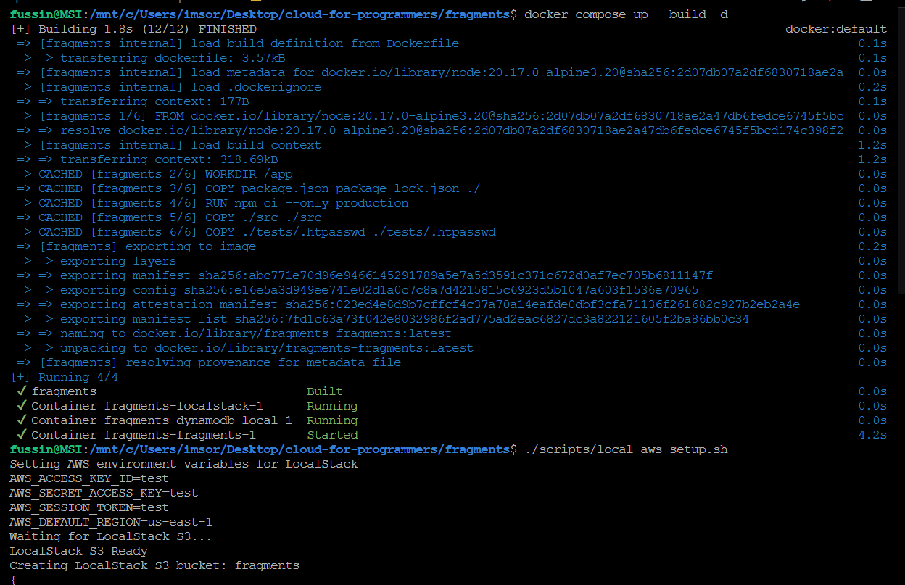
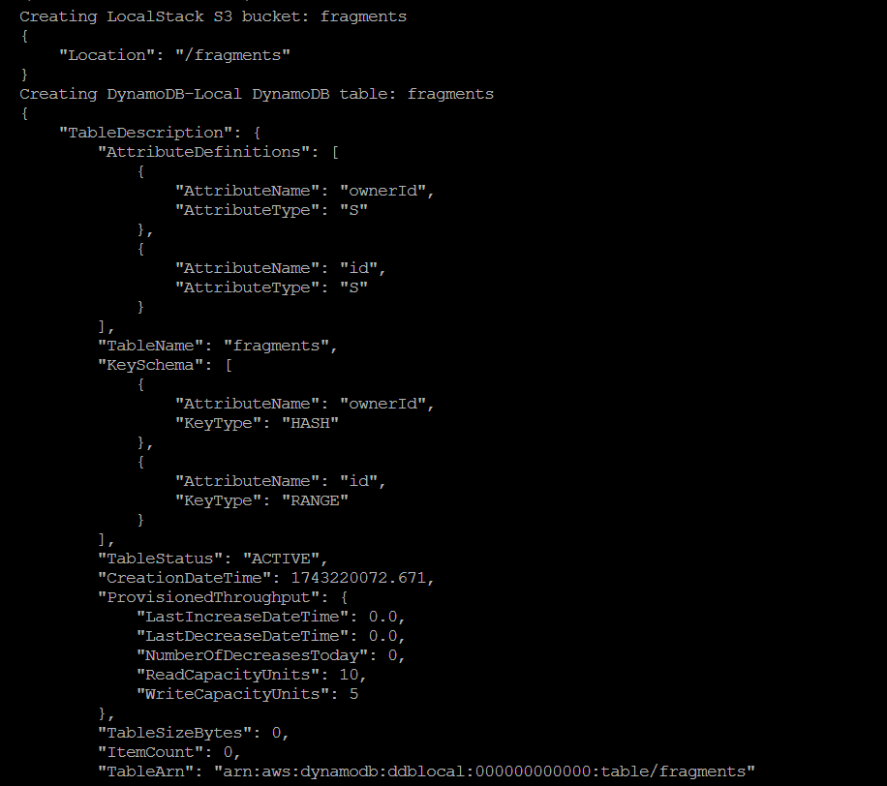
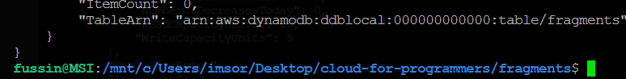
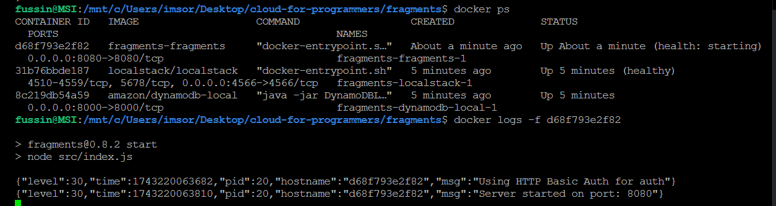
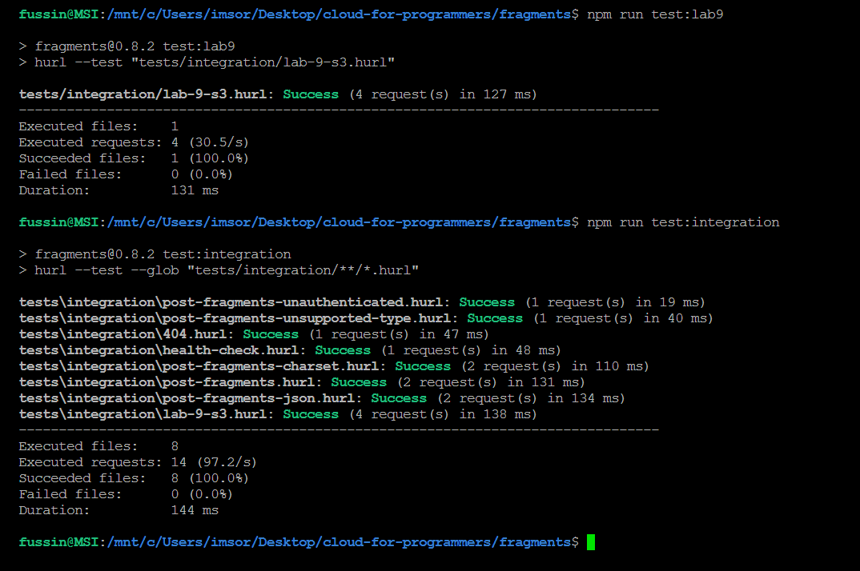

Fragments UI creating fragment using ECS
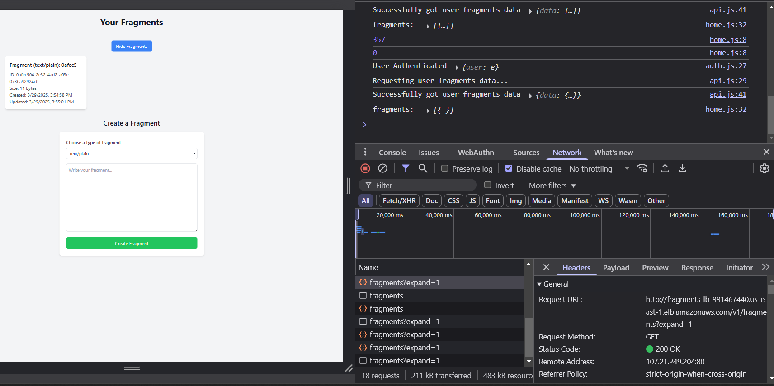
Network Tab
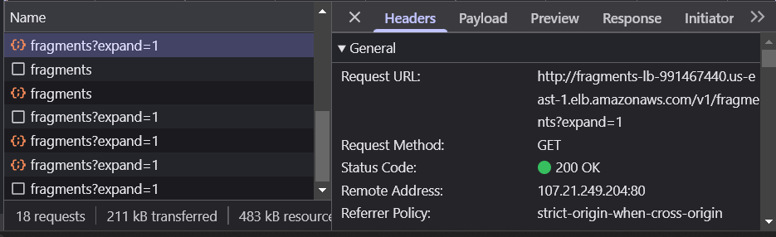
AWS S3 Console in the Bucket
